EMPLOYEE DATABASE

show databases;

create database Employee_Database_157;

use Employee_Database_157;

create table Dept_157(

DeptNo varchar(20),

DName varchar(20),

DLoc varchar(20),

primary key(DeptNo));

create table Employee_157(

EmpNo int,

EName varchar(20),

MgrNo int,

HireDate varchar(20),

Sal float,

DeptNo varchar(20),

primary key(EmpNo,DeptNo),

foreign key(DeptNo) references Dept_157(DeptNo));

create table Project_157(

PNo int,

PLoc varchar(20),

PName varchar(20),

primary key(PNo));

create table Incentives_157(

EmpNo int,

IncentiveDate varchar(20),

IncentiveAmount float,

primary key(IncentiveDate,EmpNo),

foreign key(EmpNo) references Employee_157(EmpNo));

create table AssignedTo_157(

EmpNo int,

PNo int,

JobRole text,

primary key(EmpNo,PNo),

foreign key(EmpNo) references Employee_157(EmpNo),

foreign key(PNo) references Project_157(PNo));

insert into Dept_157 values(1,"cse","Banglore");

insert into Dept_157 values(2,"ise","Chennai");

insert into Dept_157 values(3,"csds","Delhi");

insert into Dept_157 values(4,"ece","Bombay");

insert into Dept_157 values(5,"aiml","Mysore");

insert into Employee_157 values(101,"mdr",100,"12/01/1999",100000,1);

insert into Employee_157 values(201,"sak",200,"17/01/2020",50000,2);

insert into Employee_157 values(301,"grp",100,"01/09/2004",30000,3);

insert into Employee_157 values(401,"sws",101,"03/08/2000",10000,4);

insert into Employee_157 values(501,"sks",101,"29/02/2008",90000,5);

insert into Project_157 values(10,"Banglore","chatbot" );

insert into Project_157 values(40,"Delhi","ml model" );

insert into Project_157 values(50,"Bombay","blockchain" );

insert into Project_157 values(30,"Chennai","stocks" );

insert into Project_157 values("80","Mysore","android app" );

insert into Incentives_157 values(101,"12/03/2004",50000);

insert into Incentives_157 values(201,"17/03/2024",25000);

insert into Incentives_157 values(301,"01/12/2019",15000);

insert into Incentives_157 values(401,"03/11/2019",5000);

insert into Incentives_157 values(501,"29/04/2019",45000);

insert into AssignedTo_157 values(101,10,"devops");

insert into AssignedTo_157 values(201,40,"sde");

insert into AssignedTo_157 values(301,50,"manager");

insert into AssignedTo_157 values(401,30,"jpa");

insert into AssignedTo_157 values(501,80,"pa");

select * from Dept_157;

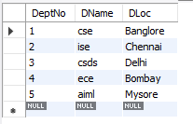

select * from Employee_157;

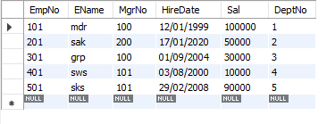

select * from Project_157;

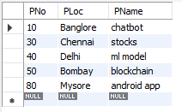

select * from Incentives_157;

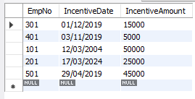

select * from AssignedTo_157;

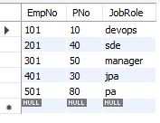

select a.EmpNo from AssignedTo_157 a

where a.PNo=any(select PNo from Project_157 where PLoc in('Banglore','Hyderabad','Mysore'));

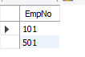

select e.EmpNo from Employee_157 e where e.EmpNo != all(select i.EmpNo from Incentives_157 i);

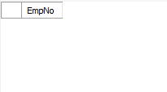

select e.EmpNo,e.EName,d.DName,a.JobRole,d.DLoc,p.PLoc

from Employee_157 e, Dept_157 d, AssignedTo_157 a, Project_157 p

where e.DeptNo=d.DeptNo and e.EmpNo=a.EmpNo and a.PNo=p.PNo

and d.DLoc=p.PLoc;

